**HOSTEL REGISTRATION FOR STUDENTS OF NIT AP**

**by**

|  |  |
| --- | --- |
| **Nadipalli Jaswanth** | **422224** |
| **Vanguri Michael** | **422268** |
| **Kushal C** | **422204** |

***Under the guidance of***

**Ms. Sonia**



**DEPARTMENT OF COMPUTER SCIENCE AND ENGINEERING NATIONAL INSTITUTE OF TECHNOLOGYANDHRA PRADESH TADEPALLIGUDEM-534102, INDIA**

**APRIL - 2024**

## HOSTEL REGISTRATION FOR STUDENTS OF NIT AP

***Thesis Submitted to***

***National Institute of Technology Andhra Pradesh***

***For the award of the degree***

***Of***

***Bachelor of Technology***

***By***

|  |  |
| --- | --- |
| **Nadipalli Jaswanth** | **422224** |
| **Vanguri Michael** | **422268** |
| **Kushal C** | **422204** |

***Under the guidance of***

**Ms. Sonia**



**DEPARTMENT OF SCIENCE AND ENGINEERING NATIONAL INSTITUTE OF TECHNOLOGYANDHRA PRADESH**

**TADEPALLIGUDEM-534102, INDIA APRIL-2024**

© 2022. All rights reserved to NIT Andhra Pradesh

**DECLARATION**

We declare that this written submission represents our ideas in our own words and where others' ideas or words have been included, we have adequately cited and referenced the original sources. We also declare that we have adhered to all principles of academic honesty and integrity and have not misrepresented or fabricated or falsified any idea/data/fact/source in our submission. We understand that any violation of the above will be cause for disciplinary action by the Institute and can also evoke penal action from the sources which have thus not been properly cited or from whom proper permission has not been taken when needed.

|  |  |  |
| --- | --- | --- |
| Nadipalli Jaswanth | Vanguri Michael | Kushal C |
| 422224 | 422268 | 422204 |
| Date: | Date: | Date: |

**CERTIFICATE**

### It is certified that the work contained in the thesis titled “HOSTEL REGISTRATION FOR STUDENTS OF NIT AP ” by “Nadipalli Jaswanth, bearing Roll No: 422224” , “Vanguri Micheal, bearing Roll No: 422268” and “Kushal C bearing Roll No: 422204” has been carried out under my supervision and that this work has not been submitted elsewhere for a degree.

**Ms .Sonia**

**Computer Science and Engineering**

**NIT Andhra Pradesh May 2023**

**ACKNOWLEDGEMENT**

The satisfaction and euphoria that accompany the successful completion of any task would be incomplete without the mention of people who made it possible, whose constant guidance and encouragement crowned our efforts with success. It is a pleasant aspect that I have now the opportunity to express my gratitude for all of them. We owe our sincere gratitude to our project guide Sireesha M, Department of Computer Science, National Institute of Technology, Andhra Pradesh, who took keen interest and guided us all along, till the completion of our project work by providing all the necessary information.

We avail ourselves of this proud privilege to express our gratitude to all the faculty of the department of Computer Science and Engineering at NIT Andhra Pradesh for emphasizing and providing us with all the necessary facilities throughout the work.

We offer our sincere thanks to all our friends, fellow mates and other persons who knowingly or unknowingly helped us to complete this project.

|  |  |  |
| --- | --- | --- |
| Nadipalli Jaswanth | Vanguri Michael | Kushal C |
| 422224 | 422268 | 422204 |
| Date: | Date: | Date |

**ABSTRACT**

Our hostel management system is a comprehensive web application designed to streamline the management of hostel facilities within educational institutions. Leveraging HTML, CSS, and JavaScript for frontend development, and Node.js with Express.js for backend functionality, our system provides an intuitive user interface for hostel administrators, staff, and residents.

Utilizing SQL with MySQL as the database management system, our application ensures efficient storage and retrieval of hostel-related data, including resident details and room allocations. This allows hostel administrators to easily manage resident information and room assignments. Real-time updates facilitate seamless communication between hostel administrators, ensuring efficient coordination in hostel management tasks.

With a focus on scalability and maintainability, our hostel management system provides a robust framework for handling diverse hostel operations, facilitating smooth coordination and management of hostels.

TABLE OF CONTENTS

CHAPTER 1

* 1. Introduction 1

CHAPTER 2

* 1. Problem Statement 2
  2. Requirements and Specification 2
     1. Software Requirements 2
     2. Technical Skills 2

CHAPTER3

|  |  |
| --- | --- |
| 3.1 Database  CHAPTER 4 | 3 |
| 4.1 Front End pages | 4 |
| CHAPTER 5  5.1. Working Procedure | 9 |
| CHAPTER 6 |  |
| 6.1 TYPESCRIPT | 11 |
| 6.2 TAILWIND CSS | 11 |
| 6.3 APPWRITE | 11 |
| 6.4 VITE | 12 |

CHAPTER 7

7.1. Conclusion 14

**Chapter - 1**

##### INTRODUCTION

In today's dynamic campus environment, effective communication and streamlined processes are paramount for facilitating hostel registration and management. Traditional methods, such as manual paperwork and in-person registrations, often lead to inefficiencies and delays. Our hostel registration system aims to address these challenges by providing an intuitive and user-friendly online platform for hostel registration and management..

Gone are the days of cumbersome paperwork and long queues. With our application, students can easily register for hostel accommodations from the comfort of their own devices. By leveraging modern web technologies such as HTML, CSS, JavaScript, Node.js, Express.js, EJS, and SQL, we offer a seamless registration experience that simplifies the entire process.

Our system ensures accurate and efficient data management, allowing hostel administrators to easily track registrations, allocate rooms, and manage resident details. Through a secure and user-friendly interface, students can submit their registration information and can view available accommodations.

By transitioning to an online platform, we aim to enhance the hostel registration experience, promoting transparency, accessibility, and efficiency for both students and administrators alike. With our hostel registration system, we pave the way for a smoother, more streamlined approach to hostel management in the campus community.

* 1. Purpose

The purpose of our hostel registration project is to modernize and streamline the process of hostel accommodation management within our college community. Our primary objective is to provide students and hostel administrators with an efficient and user-friendly platform for registering, managing, and allocating hostel accommodations. By developing this application, we aim to simplify the hostel registration process, eliminating the need for cumbersome paperwork and manual registration procedures. Our goal is to offer a seamless online solution that allows students to easily register for hostel accommodations, view available rooms and register for their desired rooms.

#### Chapter 2

#### Problem Statement

The reliance on manual registration forms and paperwork leads to inefficiencies, errors, and delays in the hostel registration process. Physical registration forms may not be readily available to all students, especially those who are off-campus or unable to visit administrative offices on time for registration. Hostel administrators often face the daunting task of manually processing and organizing large volumes of registration forms, leading to increased workload and potential errors.

# Requirements and Specifications

# Software Requirements

Operating System : Windows and Linux

Client Script : HTML,CSS,JAVASCRIPT,NODE JS,

EXPRESS JS

Component Model : Visual Studio Code

Database : MYSQL

# Technical Skills

Front-End Technology : HTML, CSS,JAVASCRIPT

Backend Technology :EXPRESS JS,NODE JS, SQL,MYSQL

Chapter -3

**Database**

Utilizing MySQL as the database management system, our project leverages its capabilities to efficiently store, retrieve, and manage hostel-related data. With MySQL, we can perform operations such as data insertion, retrieval, modification, and updating seamlessly. By harnessing the power of MySQL, our hostel registration system ensures robust database management, facilitating smooth coordination and management of hostel facilities.

**Database for storing hostel registered students**

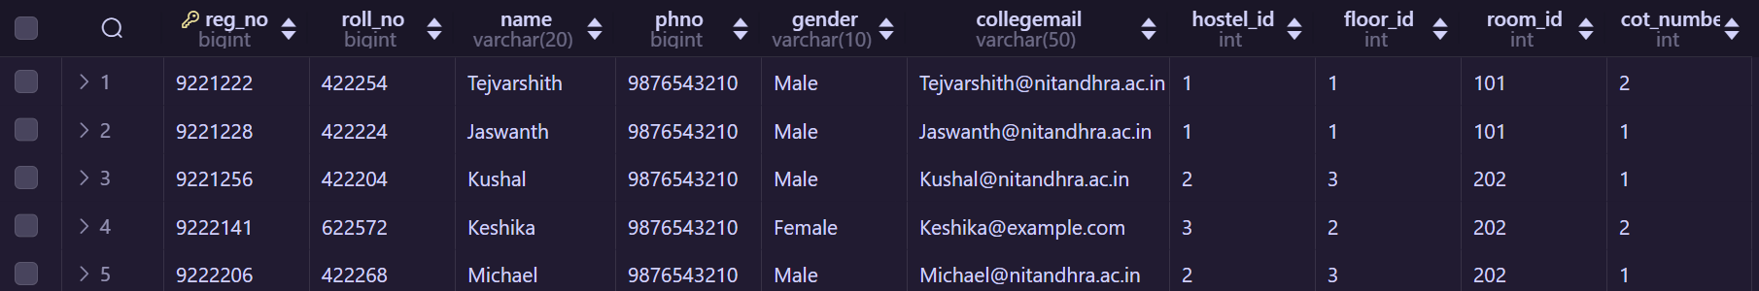

**CHAPTER 4**

Our Website contains the following Features

4.1.1 Frond end pages

1. Home page: Home page has nav-bar it contains options like “ADMINISTRATION” which leads to page

containing details of administers “HOSTELS” which directly into page which contains details of hostels

it also contains “REGISTER” which directs into login page and by login we will de directed into registration page

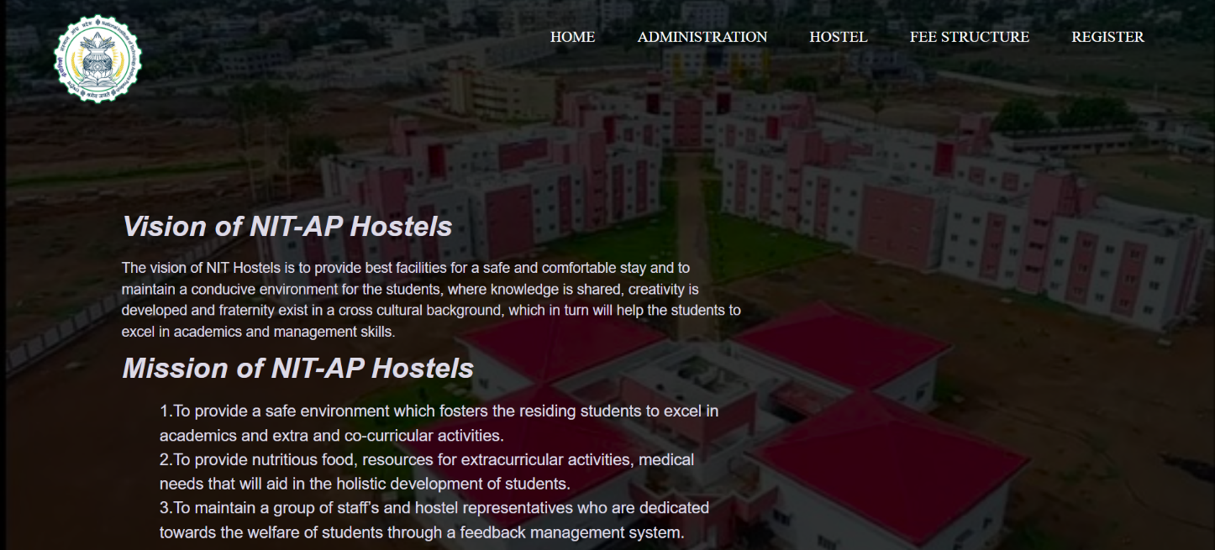

1. Registration Page : In registration page students can register for rooms at the time of registration

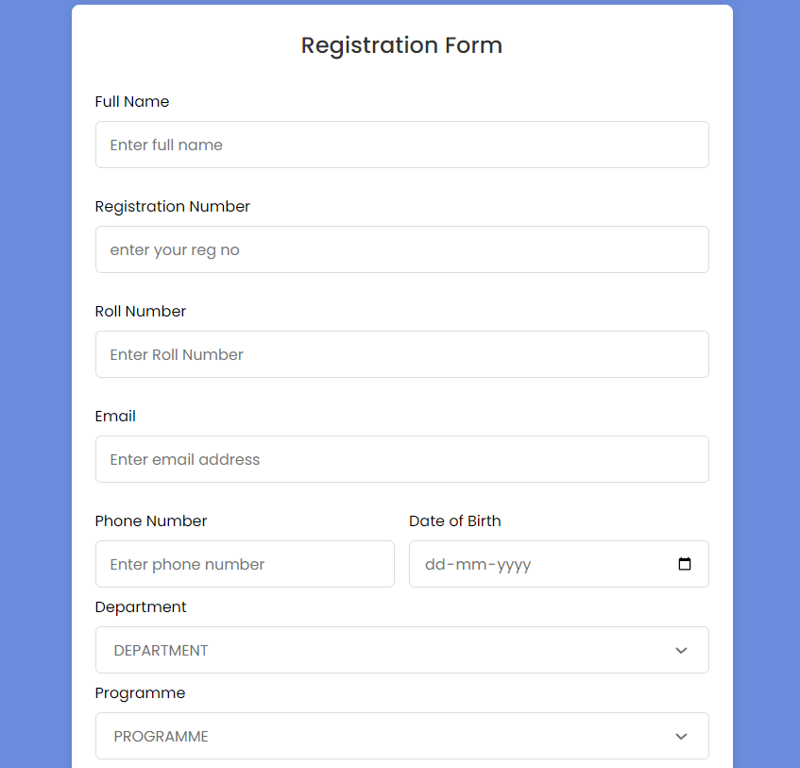

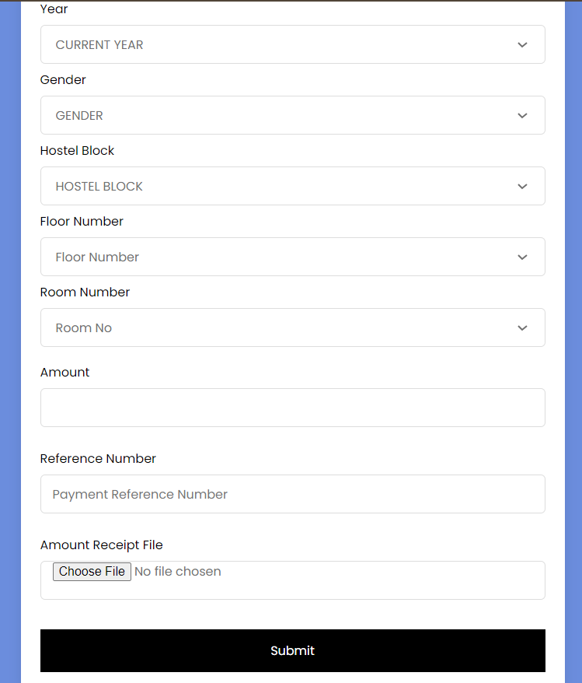

**Chapter 5**

## Working Procedure:

Sign Up:

Students should create their account using their college email and set passwords.

Login:

Whenever at the time of registration students should login using their college emails and passwords provided then they will be directly directed into the registration form for registering hostels.

Hostel Registration:

After logging they will be directed to the registration form , students should fill their details like reg no, roll no ,year.Based on their year,programme,gender they will be given hostel options based on the hostel option provided they will be shown which floors or which rooms are empty for that hostel and by selecting it they can submit their form and their details will be added to the database.Hostel admin will have access to this database.

# Chaper-6

**Technologies Used**

* 1. **HTML**

HTML (Hypertext Markup Language) is the standard markup language used for

creating web pages . It provides a structure for webpages by adding tags,

attributes,elements, links, forms . It is very important in web development and can be combined CSS and JavaScript.

* 1. **CSS**

CSS, or Cascading Style Sheets, is a programming language used to style HTML pages. CSS enhances visual appearance of a website, including font styles, colors, margins, borders, padding ,display and more. CSS works by selecting HTML elements and applying styles to them using selectors like classes , ids, div and many more. CSS can be included in HTML

document in three ways that are inline CSS, internal CSS ,external CSS

(by providing of link of CSS file in the head tag).

* 1. **JAVASCRIPT**

JavaScript is a programming language that is commonly used to add functionality to the web pages. It is a language that can be used to create interactive web pages, develop web applications. In our project we have used the framework of Javascript to connect to the server.

* 1. **NODE JS**

Node Js is used to connect frond end and backend web servers. Express is a commonly

used framework in Nodejs. Body-parser module in Node Js is used to obtain the data

from the frond end pages ,parse the data and provide it to the requests. Node js Provides

CRUD operations.Node.js also includes a package manager called NPM, which

makes it easy to install and manage third-party modules and libraries. In Our Project we

will included express,sql.

* 1. **EXPRESS JS**

Express.js, being a commonly used framework in Node.js, facilitates the development of web applications by providing a robust set of features and middleware. In the context of our hostel registration project, Express.js is employed to handle routing, middleware integration, and request handling. For instance, we have defined routes in Express.js to handle various HTTP requests related to hostel registration, such as handling GET and POST requests for rendering registration forms and processing form submissions. Additionally, Express.js might be used to serve static files, such as HTML, CSS, and client-side JavaScript files. Furthermore, Express.js middleware, including body-parser, may be utilized to parse incoming request bodies and extract data from form submissions, enabling you to process and validate user input effectively. Overall, Express.js serves as the backbone of your project, providing a structured and efficient way to handle HTTP requests and build a robust hostel registration system.

* 1. **SQL**

SQL is utilized as the primary database querying language for managing hostel-related data. SQL (Structured Query Language) enables to interact with the database management system (MySQL in our project) to perform various operations such as creating and modifying database schemas, inserting, updating, and deleting records, and retrieving data based on specific criteria. SQL queries are used to store and retrieve information related to hostel registration, resident details, room allocations, and other relevant data points. By structuring your database schema and executing SQL queries effectively, you can ensure efficient storage, retrieval, and manipulation of data within your hostel management system, providing a solid foundation for managing hostel operations seamlessly.

* 1. **MYSQL**

In your project, MySQL serves as the relational database management system (RDBMS) for storing and organizing hostel-related data. MySQL enables you to create and manage database structures that align with the requirements of your hostel management system, including tables for storing information such as student details, room allocations, hostel facilities, and administrative records. Utilizing MySQL, you can define the structure of each table, specifying data types, constraints, and relationships between entities.

**Chapter-7**

**Conclusion**

In conclusion, the hostel registration system plays a crucial role in streamlining the management of hostel facilities and enhancing the overall experience for residents. By implementing this system, administrators can efficiently handle resident registrations, room allocations, and facility management tasks. This not only simplifies administrative processes but also ensures a seamless experience for hostel residents. With features such as user-friendly interfaces and real-time updates, the hostel registration system promotes transparency and efficiency in hostel operations. Overall, the system contributes to a more organized and conducive living environment for hostel residents, fostering a positive experience and enhancing satisfaction levels.

**References**

HTML Tutorial (w3schools.com) for html https://[www.w3schools.com/css](http://www.w3schools.com/css) for CSS

JavaScript Tutorial (w3schools.com) for java script SQL Tutorial (w3schools.com) https://dev.mysql.com/doc/